Policies_Verifying Agency Billed Policy_Instance43_01-Jun-2018_05-07-38_AM_SingleSignOn.png

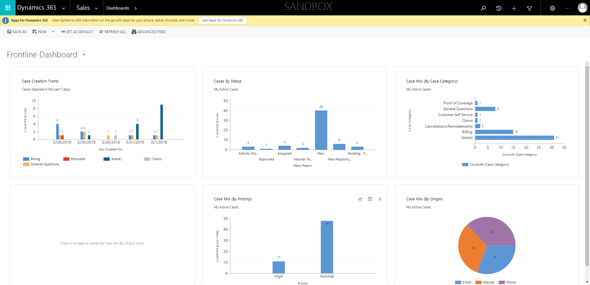

Policies_Verifying Agency Billed Policy_Instance43_01-Jun-2018_05-08-01_AM_ValidationofAgencyBilledPolicy.png

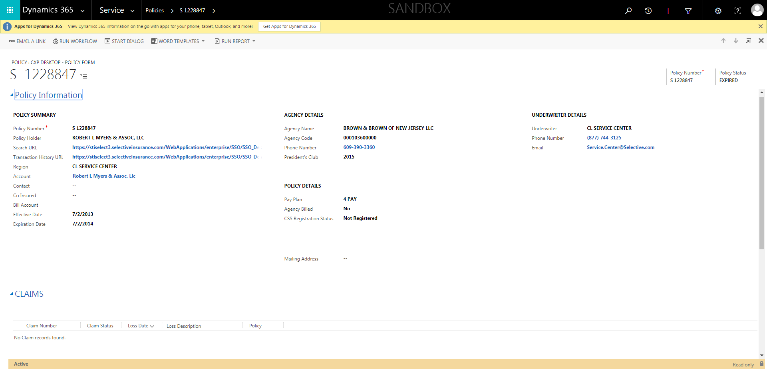

Policies_Verifying Agency Billed Policy_Instance43_01-Jun-2018_05-07-33_AM_SingleSignOn.png

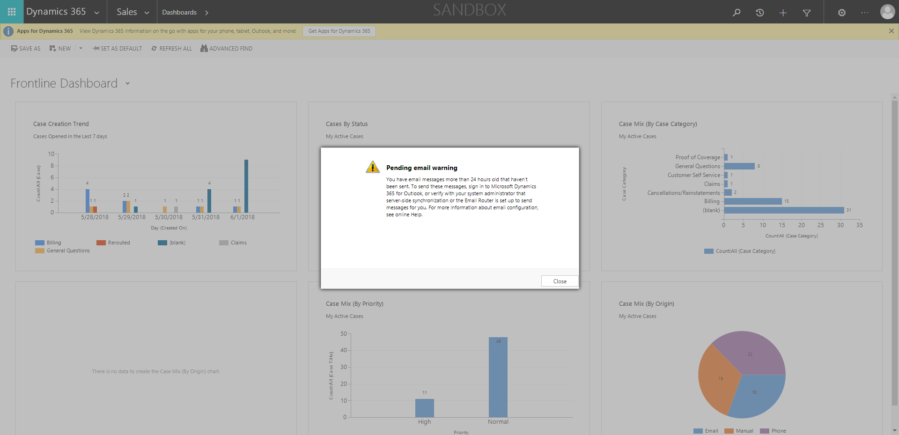

Policies_Verifying Agency Billed Policy_Instance43_01-Jun-2018_05-07-05_AM_MouseClickActiononStaleElement.png

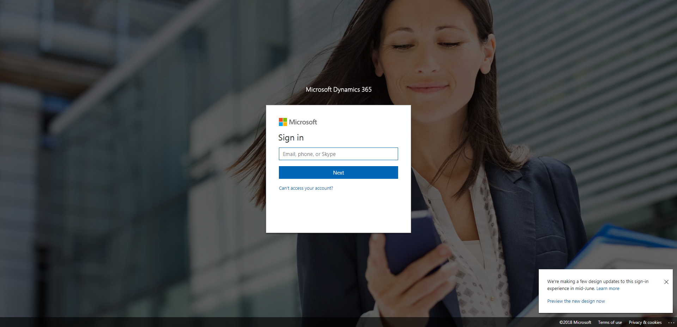

Policies_Verifying Agency Billed Policy_Instance43_01-Jun-2018_05-07-08_AM_MouseClickActiononStaleElement.png



Policies_Verifying Agency Billed Policy_Instance43_01-Jun-2018_05-07-07_AM_EnterTextAction.png

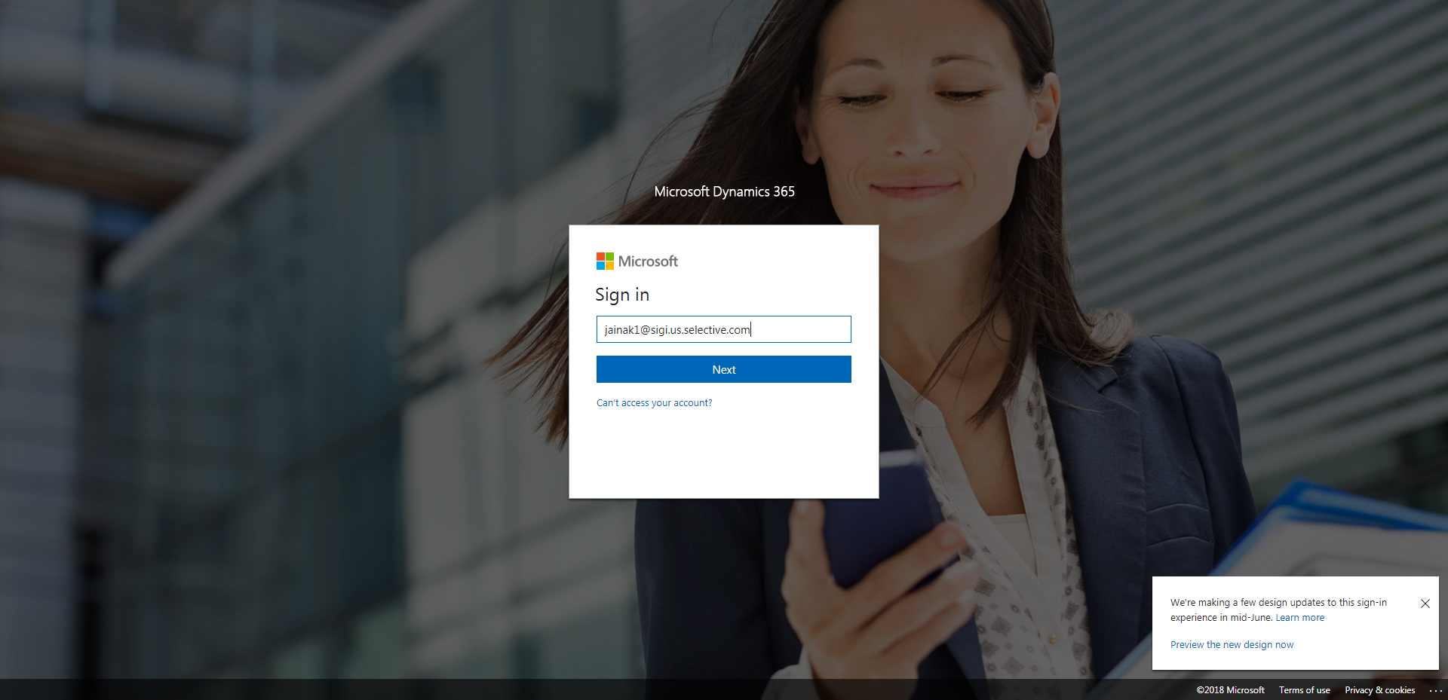

Policies_Verifying Agency Billed Policy_Instance43_01-Jun-2018_05-07-55_AM_ValidatingPolicysubentitynavigation.png

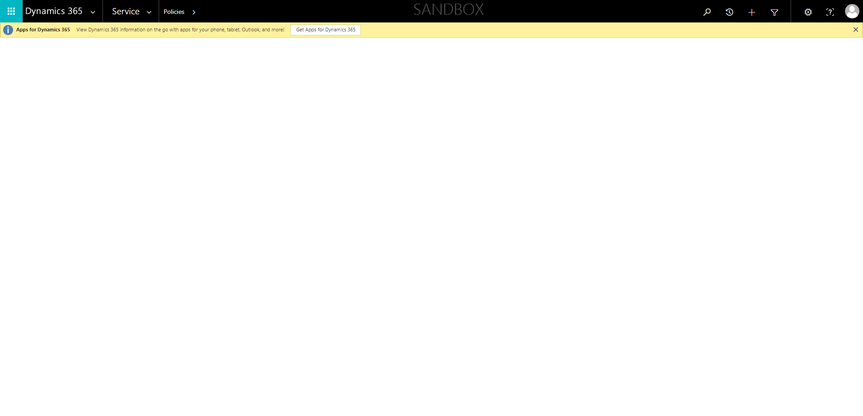

Policies_Verifying Agency Billed Policy_Instance43_01-Jun-2018_05-07-48_AM_ValidatingPolicyentitynavigation.png

